**Project Design Phase-II**

**Data Flow Diagram & User Stories**

|  |  |
| --- | --- |
| Date | 21 October 2022 |
| Team ID | PNT2022TMID03512 |
| Project Name | Project - Real-Time Communication System Powered by AI for Specially Abled |
| Maximum Marks | 4 Marks |



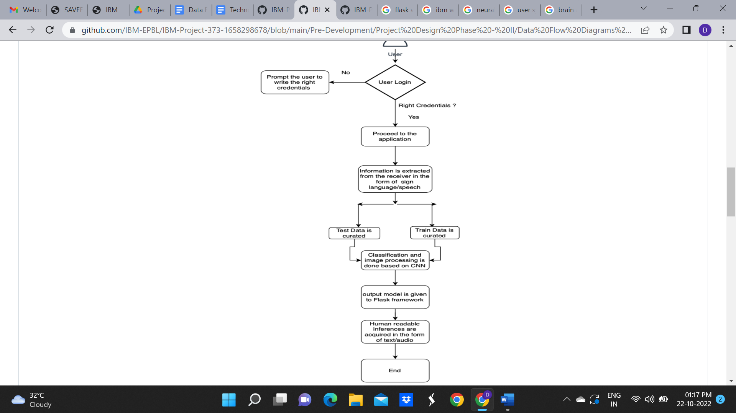

**User Stories**

Use the below template to list all the user stories for the product.

| **User Type** | **Functional Requirement (Epic)** | **User Story Number** | **User Story / Task** | **Acceptance criteria** | **Priority** | **Release** |
| --- | --- | --- | --- | --- | --- | --- |
| Customer (Mobile user) | Registration | USN-1 | As a user, I can register for the application by entering my email, password, and confirming my password. | I can access my account / dashboard | High | Sprint-1 |
| Customer Details | Login | USN-2 | As a user, I will receive confirmation email once I have registered for the application | I can receive confirmation email & click confirm | High | Sprint-1 |
| Customer Uses | Dashboard | USN-3 | As a user, I can register for the application through Facebook | I can register & access the dashboard with Facebook Login | Low | Sprint-2 |
| Customer Options | Details about the application | USN-4 | As a user, I can register for the application through Gmail | I can register and access the dashboard with Gmail Login | Medium | Sprint-1 |
| Customer usage | Login | USN-5 | As a user, I can log into the application by entering email & password | The right credentials needs to be added so that I can have a successful login and access the information on demand | High | Sprint-1 |
| Customer needs to do | Dashboard | USN-6 | Know how to use the application and understand what the specially abled people are trying to communication and vice versa | Communication must be understandable both ways through the application | High | Sprint-2 |
| Customer (Web user) | Web page | USN-7 | As a user, I can try to understand the specially abled people through the web page application virtually | Understanding of information is easily done through the application | High | Sprint-3 |
| Customer Care Executive | A chatbot or a person is used to clear all our queries and problems | USN-8 | As a user, I can assess customer service and my necessary queries are cleared. | If I have queries and doubts, then I can approach customer service and they will accessible any time | Medium | Sprint-4 |
| Administrator | Supervise the entire procedure and act as | USN-9 | Asks as a mediator to solve all the queries between the user and the speaker. | Work can be done at a faster rate | High | Sprint-4 |